**Chat App Demo**

1. Firstly, to run chat app, the server needs to run before. Now, the server status will show message: “Server started!”.

1. At the beginning, the client will open “client connector” window with 2 methods, including: login and signup.

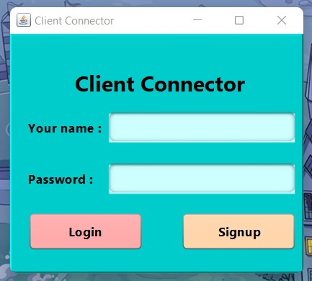

1. If user try to login without register, the system will show “not exist” notification.

1. After register, the system will show successful notification, the server also adds a new user to chat room.

1. I will demo for 3 users, who login at the same time.

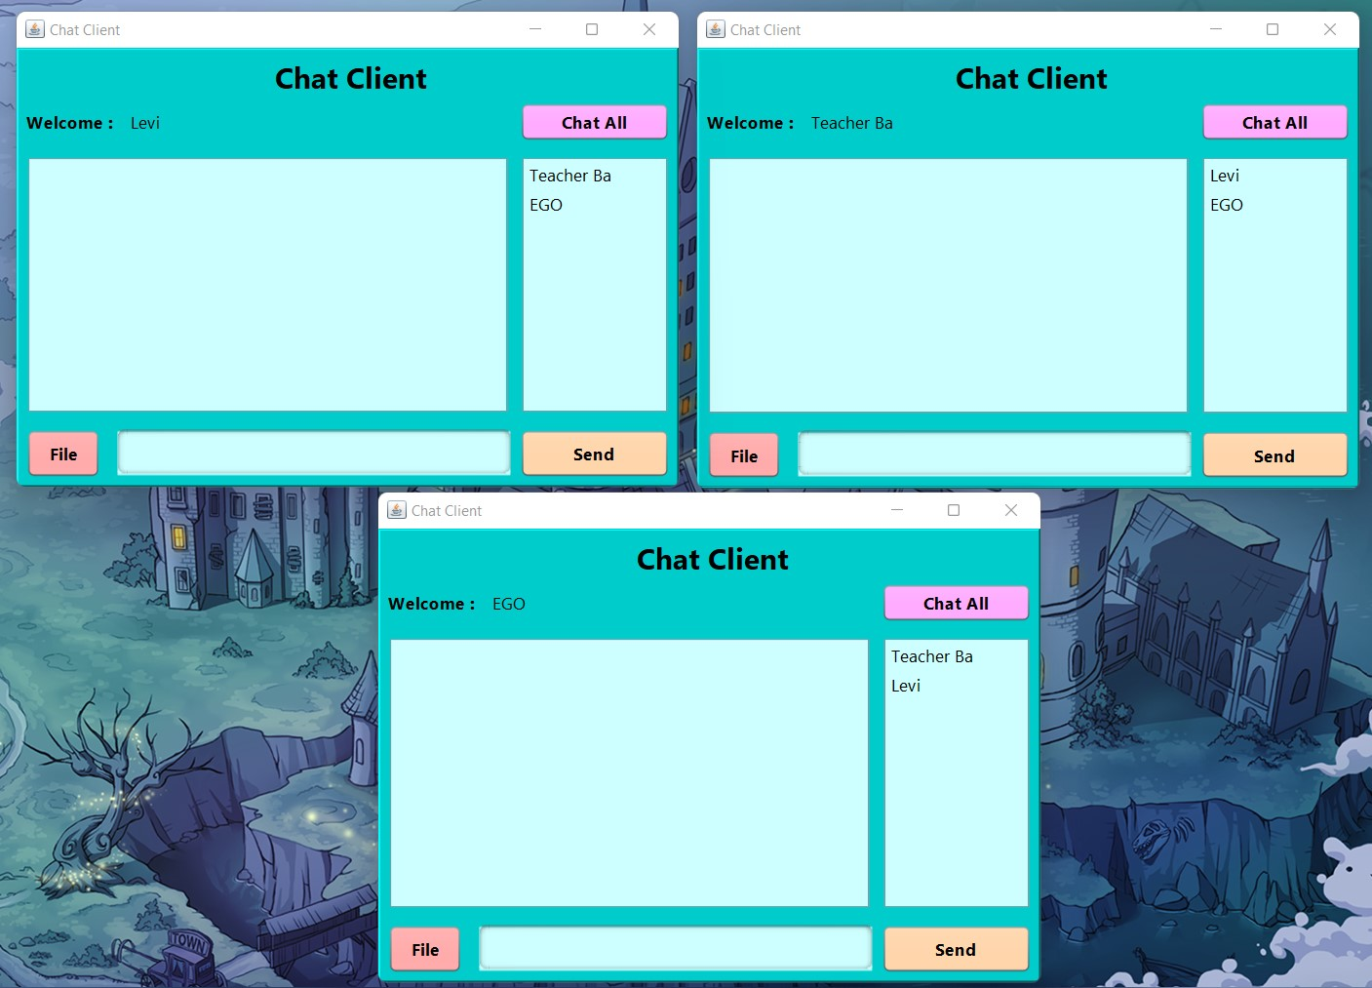

1. By default, anyone can send messages to chat room.

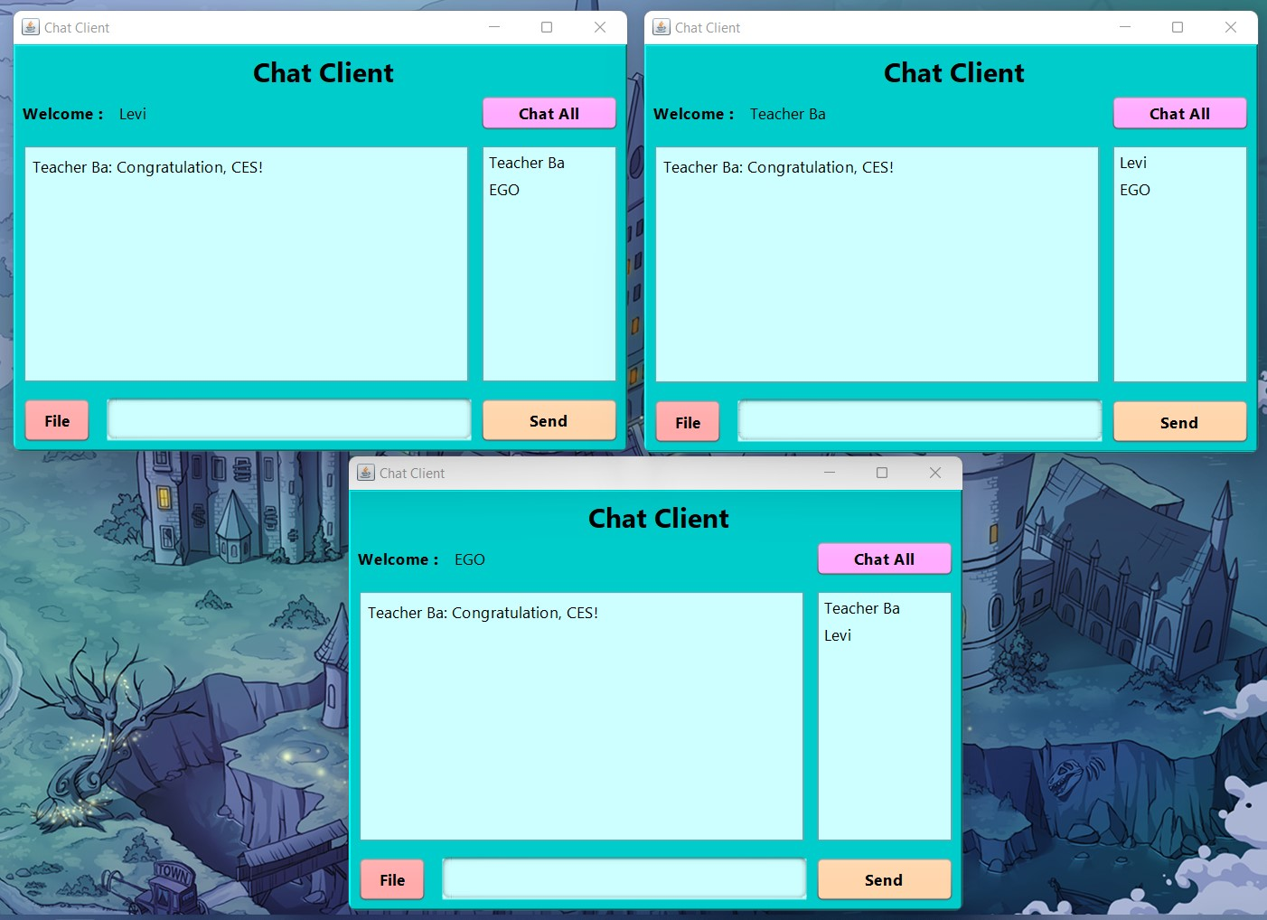

1. To chat privately, the user clicks to user who he/she wants chat to on the right column.

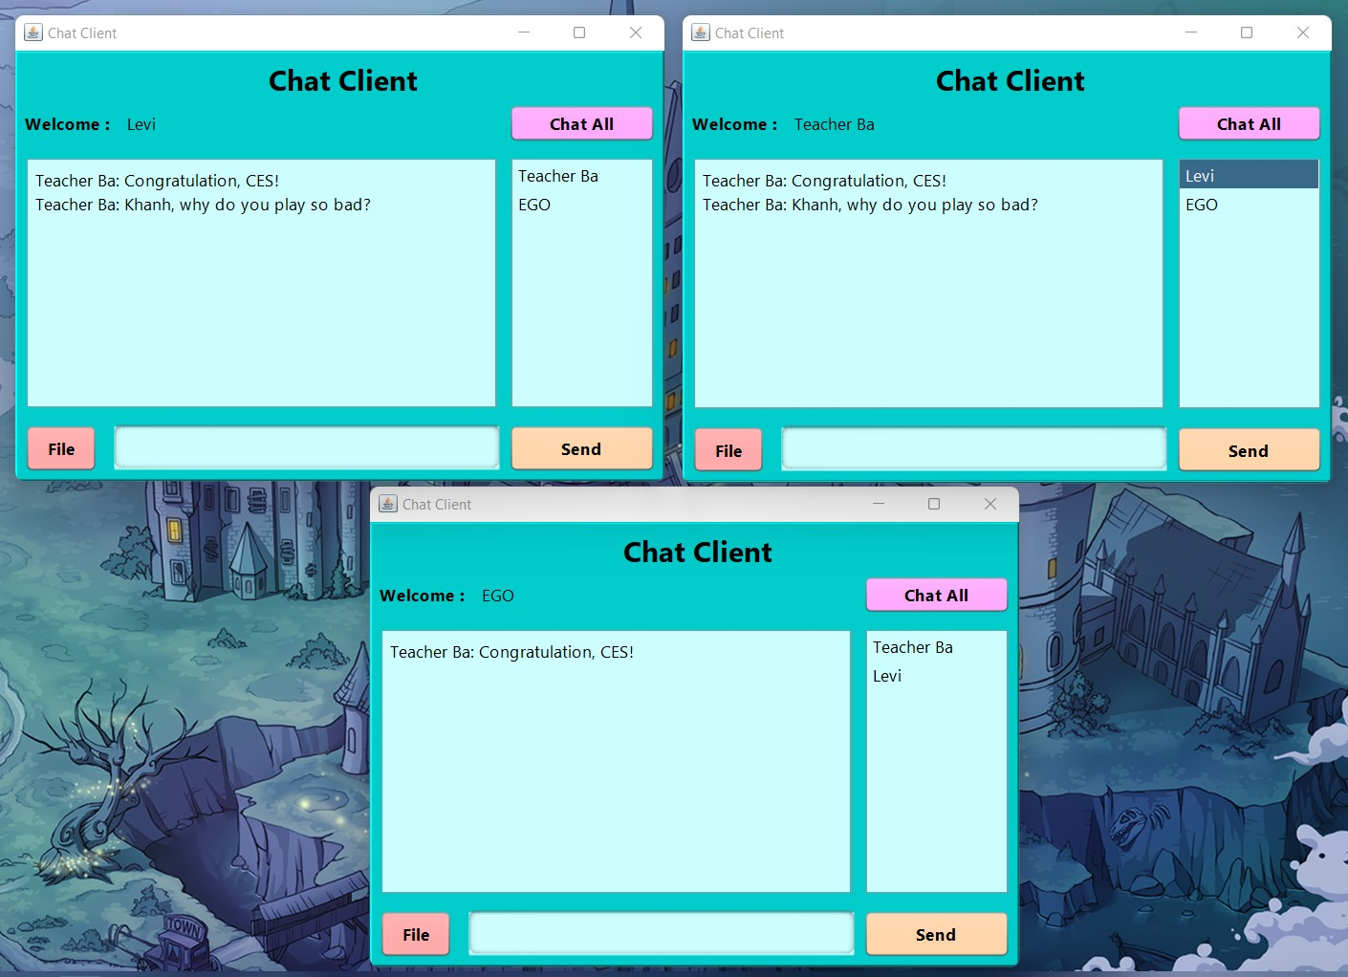

1. To come back chat room, the user just clicks on “chat all” button.

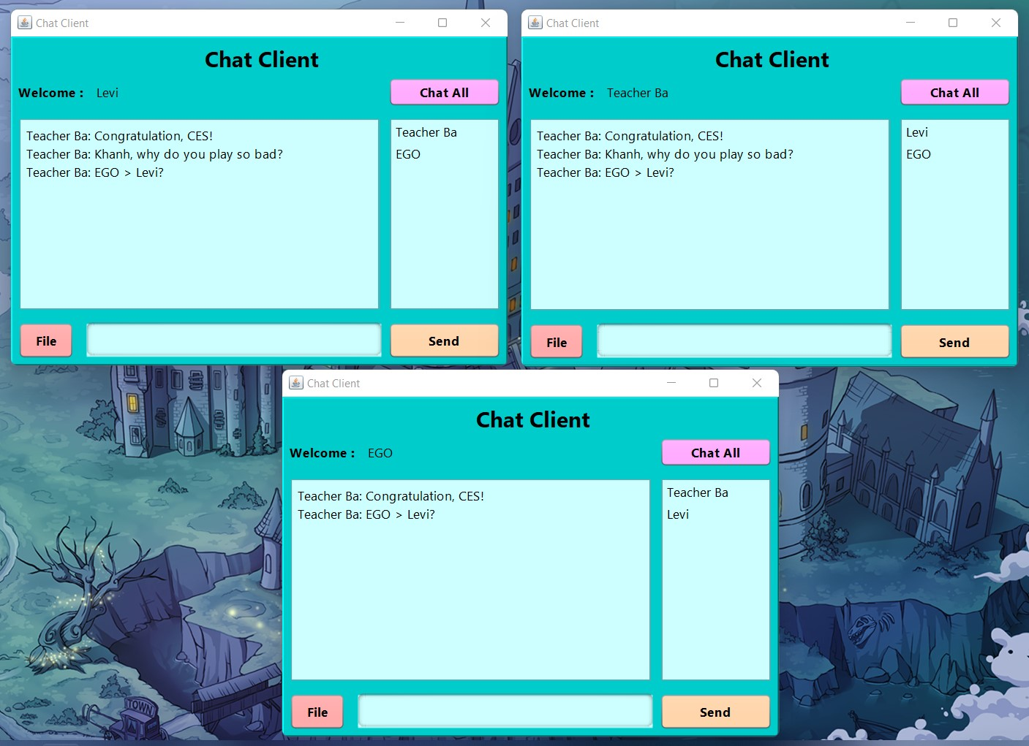

1. When a user logout from system (clicks on X), others will see that user disappear on users column, but the server still save that user’s account.

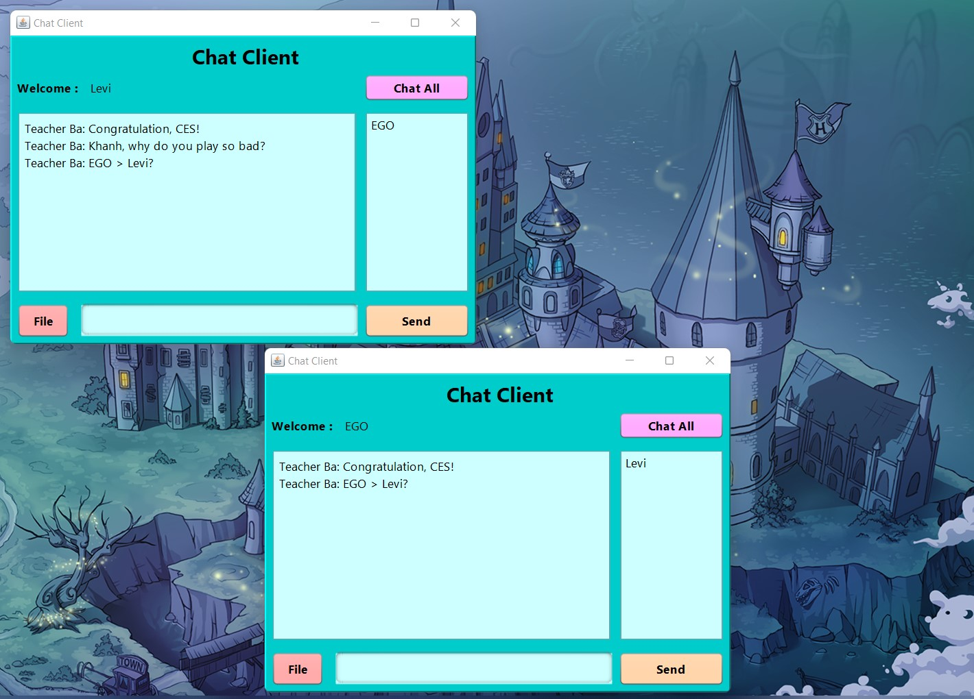

1. To return chat app, that user need to login with exact account before. If someone try to register with same name, the system will show “registered user”.

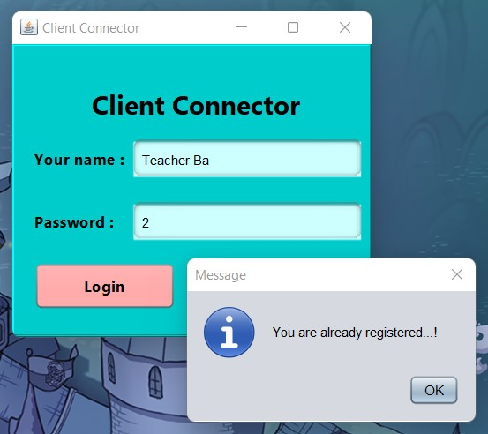

1. On the other hand, if that user enters wrong password, the notification will be shown, too.

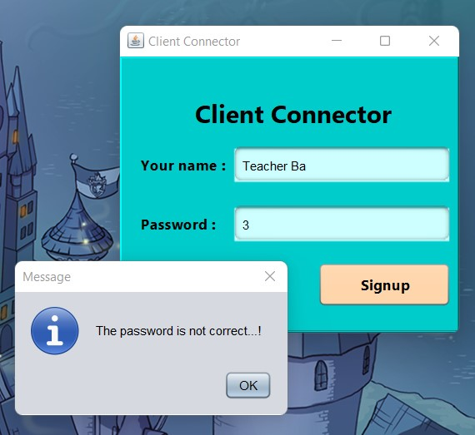

1. Now, that user can chat to everyone again.

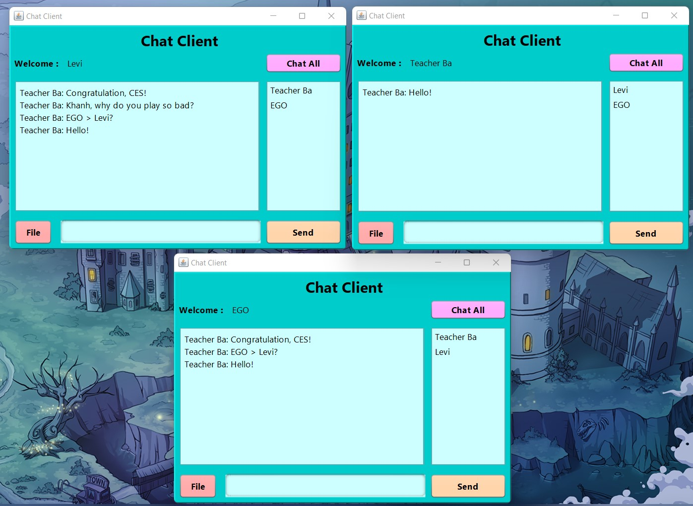

1. To send a file, the user clicks on “file” button, a new window for user to choose the path will be shown.

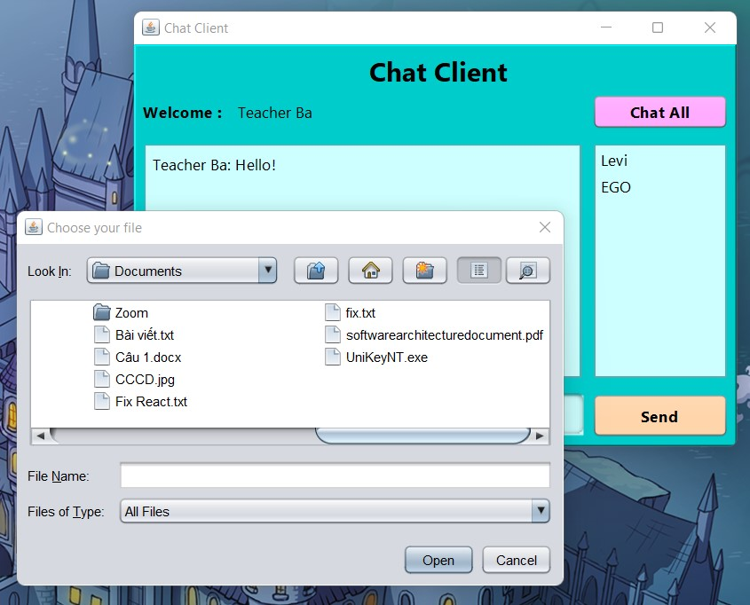

1. Then the file will appear with a new message, but this is just demo, not run with real file!

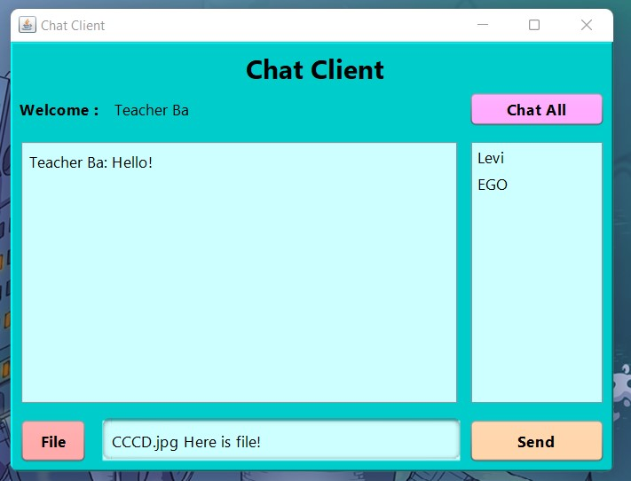

1. Finally, to solve the message security problem, all messages will be end-to-end encrypted with the Base64 library.

